Overview: FBBC Crushers are for the most part darn near bullet proof and will require a minimal amount of maintenance to keep the tool working as well as the day you first received it.
Gripping Surface: The external gripping surface is purposely left raw steel to allow it to weather in time develop a textured patina. If for some reason this is something you don’t want it’s recommended you store the crusher with a light coating of oil such as WD40 when not and use. Tip remove any chalk before spraying down the unit with WD40 that mixture makes a mess.
Roller Surface: The roller surface as shown in figure 1 should be cleaned and oiled once per year. Unless being used in a contest than it is required that the crusher is cleaned and oiled the week before the contest.
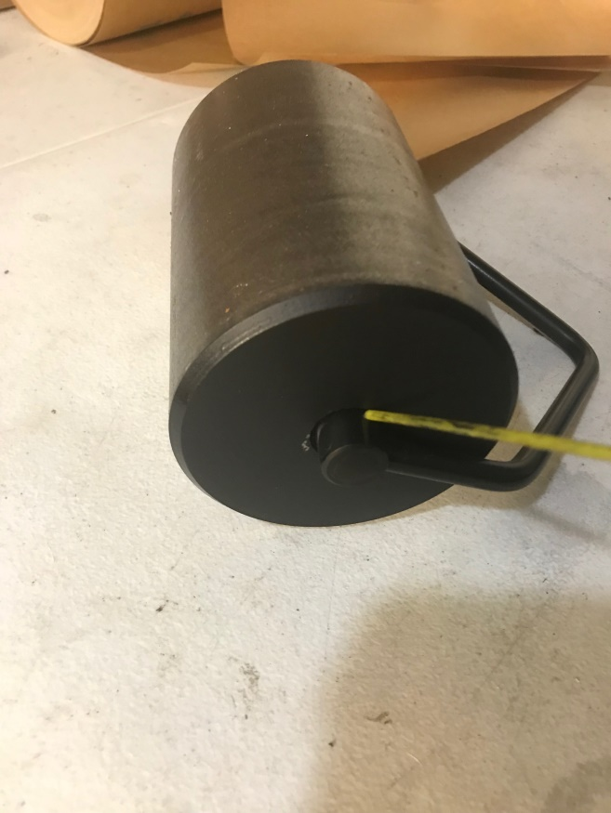 Figure 1

Cleaning Step one: Blow out the roller with compressed air. You can use either an air compressor or you can get little cans of compressed air for cleaning computer hardware for this. The purpose here is to remove and calk dust buildup that could accumulate over the year.

Cleaning Step two: Oil the gap between the center axle and the roller. I use hops 9 gun oil on the production units, however any brand of gun oil will work for this case. Other options include most spray lubricants. Just avoid grease is that will not get deep enough into the roller to be effective.

